Step 1: Create and Activate Virtual Environment (if not already)
1.sudo apt update -y
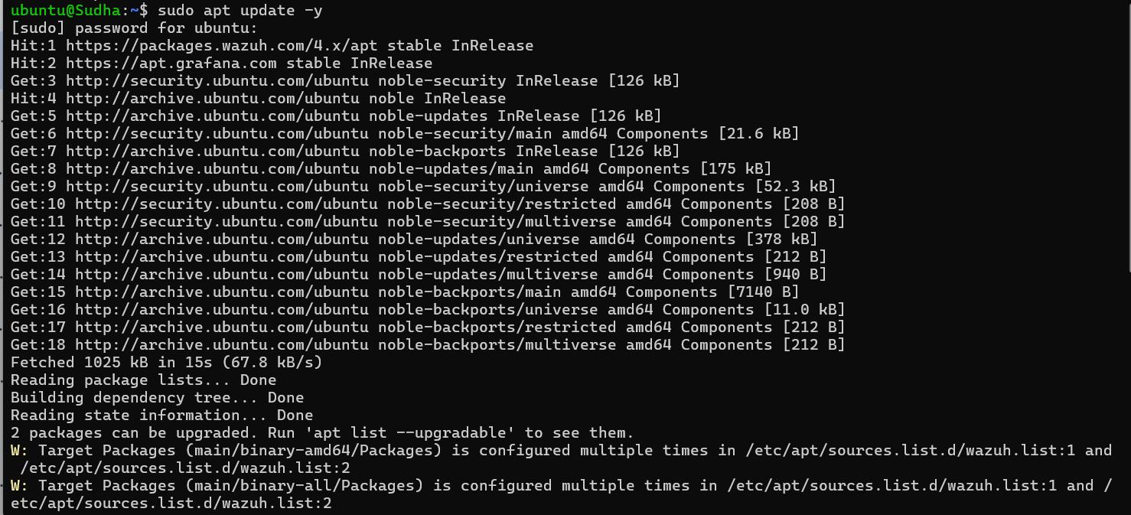
2. sudo apt install python3-pip python3.12-venv -y
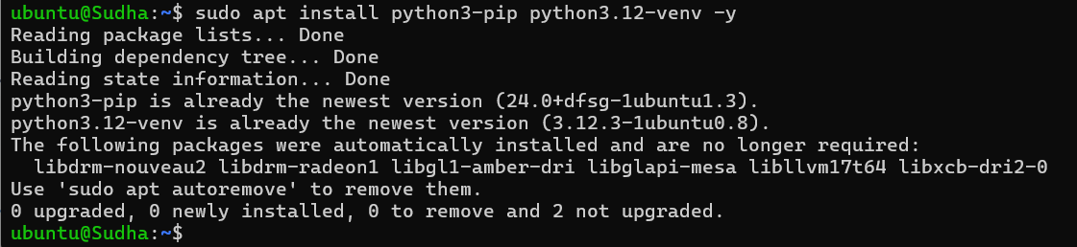
The command I ran earlier had already been executed, which is why it’s showing only partially. Normally, it takes some time to complete.
3. python3 -m venv airflow_env
source airflow_env/bin/activate
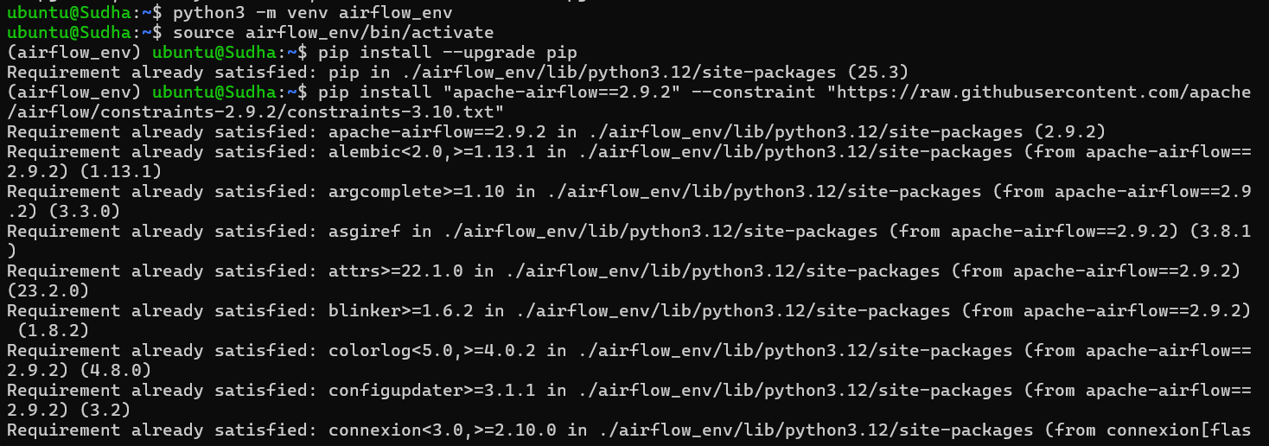
Step 2: Install Apache Airflow (Stable Version with Dependencies)
You need to add the ~/airflow_env/bin to your PATH permanently.
echo 'export PATH="$HOME/airflow_env/bin:$PATH"' >> ~/.bashrc
source ~/.bashrc
Step 4: Set Airflow Home Directory (Optional but Recommended)
By default, Airflow creates files in ~/airflow. You can choose a custom directory.
echo 'export AIRFLOW_HOME=~/airflow' >> ~/.bashrc
source ~/.bashrc
Step 5: Initialize Airflow Database
airflow db init
All the commands are run in a in taken in a single screenshot

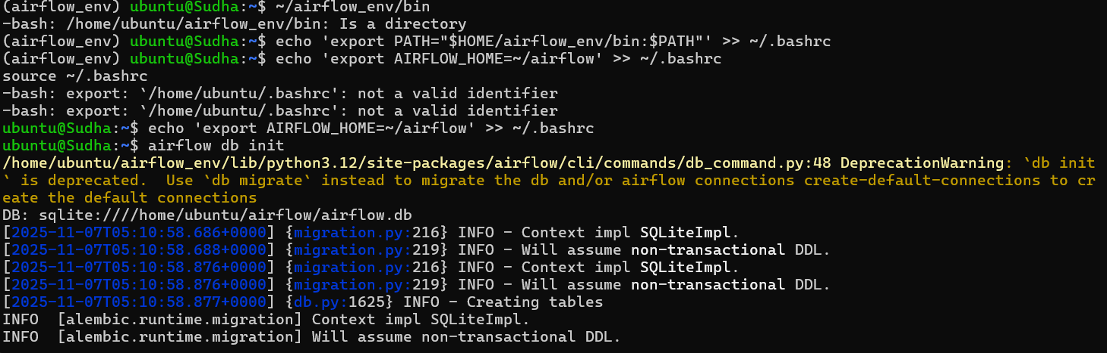
Step 6: Create Airflow Admin User
airflow users create \
--username admin \
--firstname Admin \
--lastname User \
--role Admin \
--email admin@example.com

It will ask for password → set a secure one.
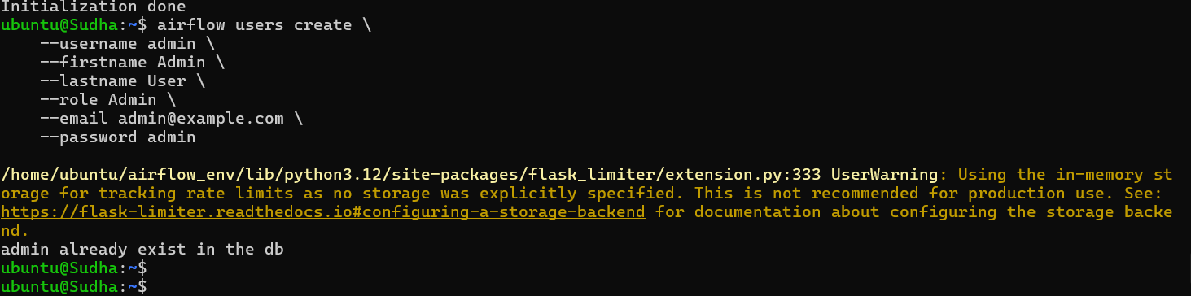
The above screenshot shows that the database exit because I have already runned this code first now when we run the second time it shows admin exist in the db
Step 7: Create folders for DAGs
mkdir -p ~/airflow/dags
Airflow will automatically look for DAGs in ~/airflow/dags.
Step 8 : Create a simple DAG
1.Open a text editor and create a file: nano ~/airflow/dags/etl_dag.py
2.Paste the following example DAG code:
from datetime import datetime
from airflow import DAG
from airflow.operators.python import PythonOperator
# Example ETL functions
def extract():
print("Extracting data...")
def transform():
print("Transforming data...")
def load():
print("Loading data...")
# Define DAG
with DAG(
'etl_dag',
start_date=datetime(2025, 11, 7),
schedule_interval='@daily',
catchup=False,
description='A simple ETL DAG with dependencies'
) as dag:
# Define tasks
extract_task = PythonOperator(
task_id='extract',
python_callable=extract
)
transform_task = PythonOperator(
task_id='transform',
python_callable=transform
)
load_task = PythonOperator(
task_id='load',
python_callable=load
)
# Define the task dependencies (graph)
extract_task >> transform_task >> load_task
Save and exit (Ctrl+O, Enter, Ctrl+X).
Step : Start Airflow services
- Start the webserver:
airflow webserver --port 8080
By default, Airflow UI will be at http://localhost:8080.
- In another terminal, activate the virtual environment and start the scheduler:
source airflow_env/bin/activate
airflow scheduler
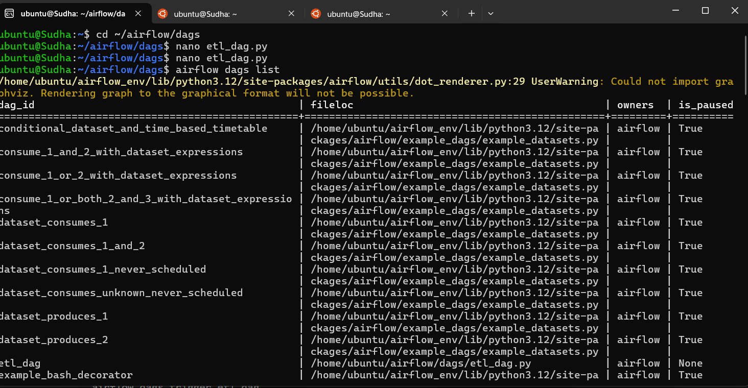
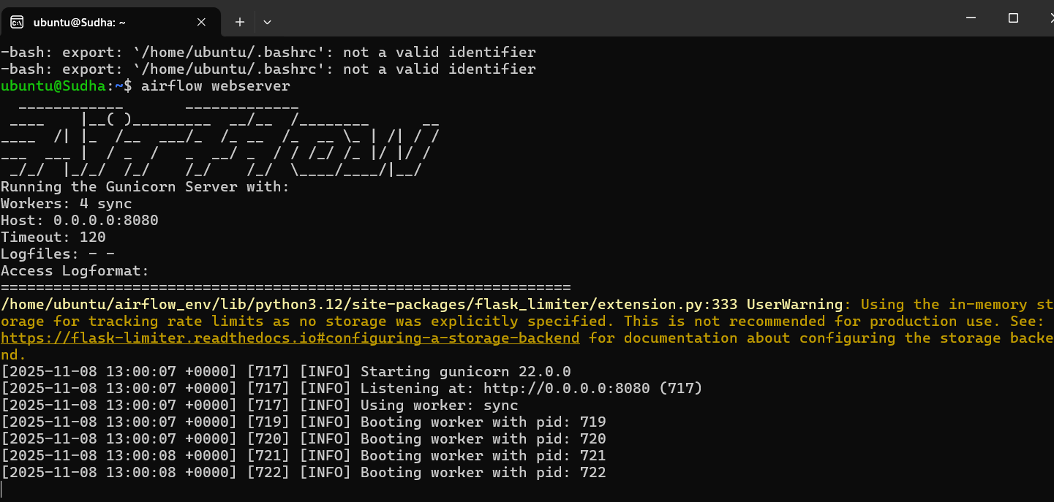
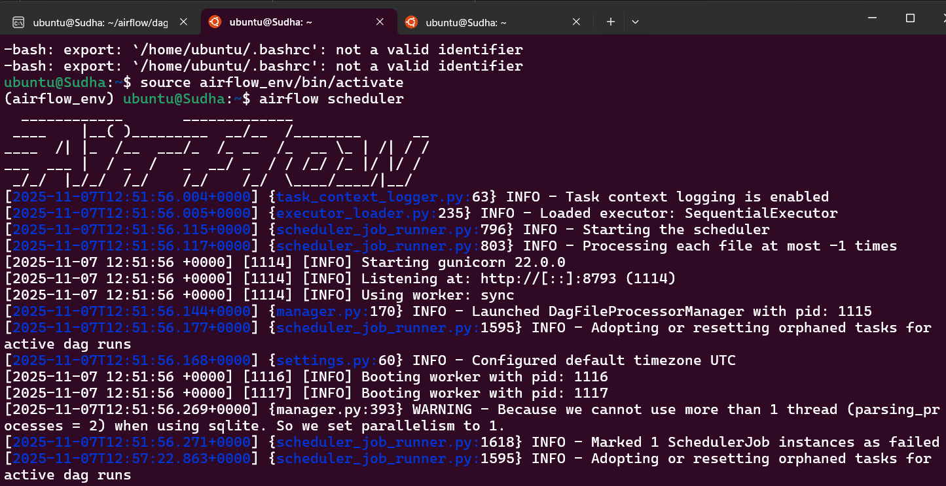

Login in using username and password

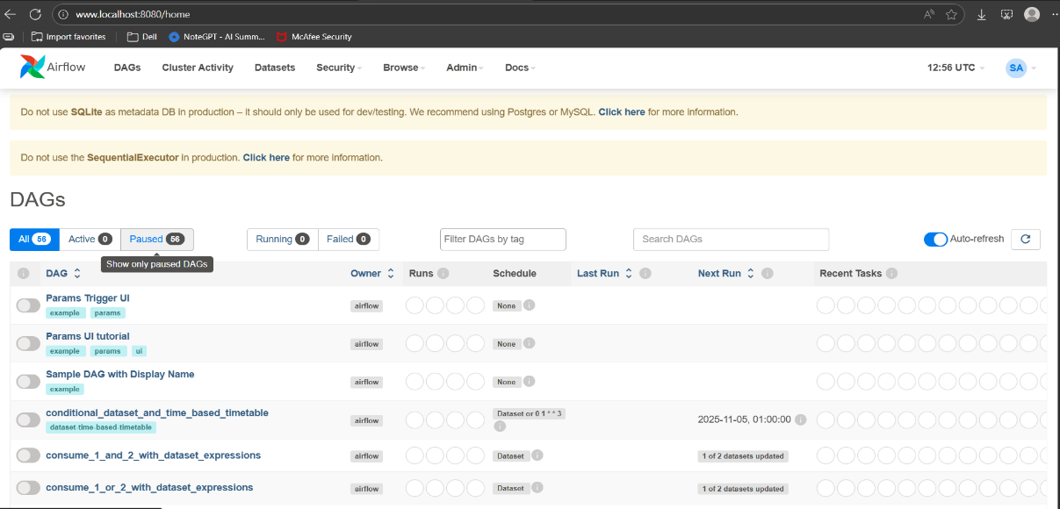
The above dag with name etl_dag is the dag which we created now using the code
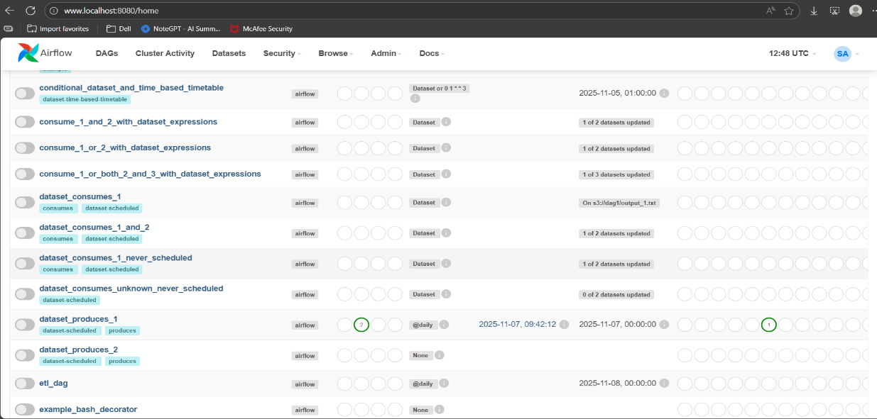
The below Sreenshot represents the detail of the dag
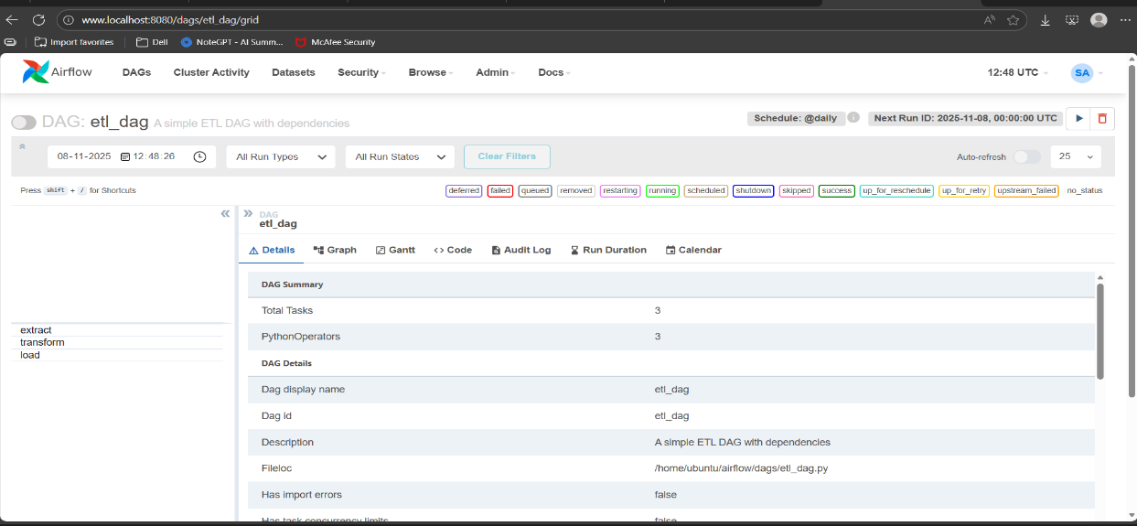
The below screenshot represents the graph of the dag
